Review article

The epidemiology and pathogenesis of coronavirus disease (COVID-19) outbreak

Hussin A. Rothana, Siddappa N. Byrareddyb,c,d,∗

a *Department of Biology, College of Arts and Sciences, Georgia State University, Atlanta, GA, USA*

b *Department of Pharmacology and Experimental Neuroscience, University of Nebraska Medical Centre, Omaha, NE, USA*

c *Department of Genetics, Cell Biology and Anatomy, Omaha, NE, USA*

d *Department of Biochemistry and Molecular Biology, University of Nebraska Medical Centre, Omaha, NE, USA*

A R T I C L E I N F O

*Keywords:* Coronavirus COVID-19

Wuhan city Pneumonia Pathogenesis

A B S T R A C T

Coronavirus disease (COVID-19) is caused by SARS-COV2 and represents the causative agent of a potentially fatal disease that is of great global public health concern. Based on the large number of infected people that were exposed to the wet animal market in Wuhan City, China, it is suggested that this is likely the zoonotic origin of COVID-19. Person-to-person transmission of COVID-19 infection led to the isolation of patients that were sub- sequently administered a variety of treatments. Extensive measures to reduce person-to-person transmission of COVID-19 have been implemented to control the current outbreak. Special attention and eﬀorts to protect or reduce transmission should be applied in susceptible populations including children, health care providers, and elderly people. In this review, we highlights the symptoms, epidemiology, transmission, pathogenesis, phylo- genetic analysis and future directions to control the spread of this fatal disease.

1. Introduction

Coronavirus is one of the major pathogens that primarily targets the human respiratory system. Previous outbreaks of coronaviruses (CoVs) include the severe acute respiratory syndrome (SARS)-CoV and the Middle East respiratory syndrome (MERS)-CoV which have been pre- viously characterized as agents that are a great public health threat. In late December 2019, a cluster of patients was admitted to hospitals with an initial diagnosis of pneumonia of an unknown etiology. These pa- tients were epidemiologically linked to a seafood and wet animal wholesale market in Wuhan, Hubei Province, China [1,2]. Early reports predicted the onset of a potential Coronavirus outbreak given the es- timate of a reproduction number for the 2019 Novel (New) Coronavirus (COVID-19, named by WHO on Feb 11, 2020) which was deemed to be signiﬁcantly larger than 1 (ranges from 2.24 to 3.58) [3].

The chronology of COVID-19 infections is as follows. The ﬁrst cases

were reported in December 2019 [4]. From December 18, 2019 through December 29, 2019, ﬁve patients were hospitalized with acute re- spiratory distress syndrome and one of these patients died[5]. By Jan- uary 2, 2020, 41 admitted hospital patients had been identiﬁed as having laboratory-conﬁrmed COVID-19 infection, less than half of these patients had underlying diseases, including diabetes, hypertension, and

cardiovascular disease [6]. These patients were presumed to be infected in that hospital, likely due to nosocomial infection. It was concluded that the COVID-19 is not a super-hot spreading virus (spread by one patient to many others), but rather likely spread due to many patients getting infected at various locations throughout the hospital through unknown mechanisms. In addition, only patients that got clinically sick were tested, thus there were likely many more patients that were pre- sumably infected. As of January 22, 2020, a total of 571 cases of the 2019-new coronavirus (COVID-19) were reported in 25 provinces (districts and cities) in China [7]. The China National Health Com- mission reported the details of the ﬁrst 17 deaths up to January 22, 2020. On January 25, 2020, a total of 1975 cases were conﬁrmed to be infected with the COVID-19 in mainland China with a total of 56 deaths [8]. Another report on January 24, 2020 estimated the cumulative in- cidence in China to be 5502 cases [9]. As of January 30, 2020, 7734 cases have been conﬁrmed in China and 90 other cases have also been reported from a number of countries that include Taiwan, Thailand, Vietnam, Malaysia, Nepal, Sri Lanka, Cambodia, Japan, Singapore, Republic of Korea, United Arab Emirates, United States, The Phi- lippines, India, Australia, Canada, Finland, France, and Germany. The case fatality rate was calculated to be 2.2% (170/7824) [10]. The ﬁrst case of COVID-19 infection conﬁrmed in the United States led to the

description, identiﬁcation, diagnosis, clinical course, and management of this case. This includes the patient's initial mild symptoms at pre- sentation and progression to pneumonia on day 9 of illness [11]. Fur- ther, the ﬁrst case of human-to-human transmission of COVID-19 was reported in the US on January 30, 2020 ([https://www.cdc.gov/media/](https://www.cdc.gov/media/releases/2020/p0130) [releases/2020/p0130](https://www.cdc.gov/media/releases/2020/p0130)). The CDC has so far screened > 30,000 passen- gers arriving at US airports for the novel coronavirus. Following such initial screening, 443 individuals have been tested for coronavirus in- fection in 41 states in the USA. Only 15 (3.1%) were tested positive, 347 were negative and results on the remaining 81 are pending ([https://](https://www.cdc.gov/coronavirus/2019-ncov) [www.cdc.gov/coronavirus/2019-ncov](https://www.cdc.gov/coronavirus/2019-ncov)). A report published in Nature revealed that Chinese health authorities concluded that as of February 7, 2019, there have been 31,161 people who have contracted the in- fection in China, and more than 630 people have died ([http://www.](http://www.nature.com/articles/d41586-020-00154) [nature.com/articles/d41586-020-00154](http://www.nature.com/articles/d41586-020-00154)) of infection. At the time of preparing this manuscript, the World Health Organisation (WHO) re- ported 51,174 conﬁrmed cases including 15, 384 severe cases and 1666 death cases in China. Globally, the number of conﬁrmed cases as of this writing (February 16, 2020) has reached 51,857 in 25 countries ([https://www.who.int/docs/default-source/coronaviruse/situation-](https://www.who.int/docs/default-source/coronaviruse/situation-reports) [reports](https://www.who.int/docs/default-source/coronaviruse/situation-reports)) (Fig. 1).

1. Symptoms

The symptoms of COVID-19 infection appear after an incubation period of approximately 5.2 days [12]. The period from the onset of COVID-19 symptoms to death ranged from 6 to 41 days with a median of 14 days [8]. This period is dependent on the age of the patient and status of the patient's immune system. It was shorter among pa- tients > 70-years old compared with those under the age of 70 [8]. The most common symptoms at onset of COVID-19 illness are fever, cough, and fatigue, while other symptoms include sputum production, head- ache, haemoptysis, diarrhoea, dyspnoea, and lymphopenia [5,6,8,13]. Clinical features revealed by a chest CT scan presented as pneumonia, however, there were abnormal features such as RNAaemia, acute re- spiratory distress syndrome, acute cardiac injury, and incidence of grand-glass opacities that led to death [6]. In some cases, the multiple peripheral ground-glass opacities were observed in subpleural regions of both lungs [14] that likely induced both systemic and localized im- mune response that led to increased inﬂammation. Regrettably, treat- ment of some cases with interferon inhalation showed no clinical eﬀect and instead appeared to worsen the condition by progressing pul- monary opacities [14] (Fig. 2).

It is important to note that there are similarities in the symptoms

between COVID-19 and earlier betacoronavirus such as fever, dry cough, dyspnea, and bilateral ground-glass opacities on chest CT scans [6]. However, COVID-19 showed some unique clinical features that include the targeting of the lower airway as evident by upper re- spiratory tract symptoms like rhinorrhoea, sneezing, and sore throat [15,16]. In addition, based on results from chest radiographs upon

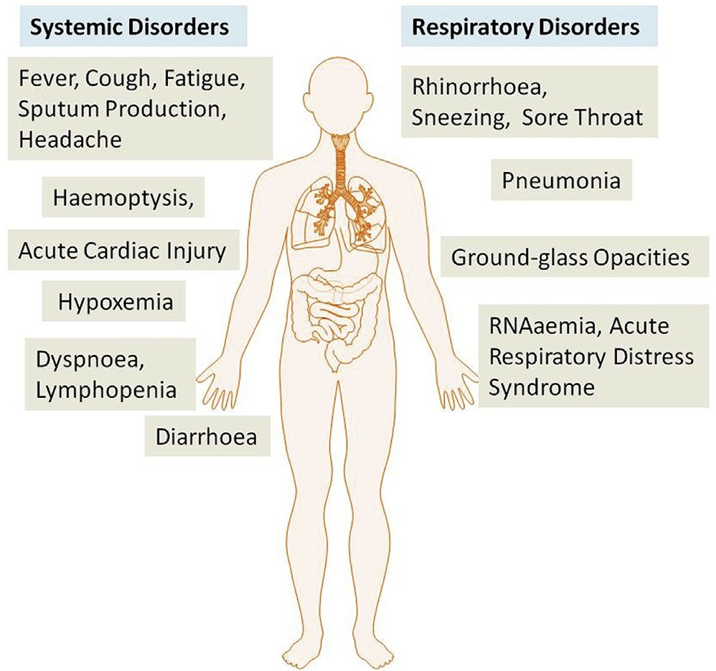

Fig. 2. The systemic and respiratory disorders caused by COVID-19 infection. The incubation period of COVID-19 infection is approximately 5.2 days. There are general similarities in the symptoms between COVID-19 and previous be- tacoronavirus. However, COVID-19 showed some unique clinical features that include the targeting of the lower airway as evident by upper respiratory tract symptoms like rhinorrhoea, sneezing, and sore throat. Additionally, patients infected with COVID-19 developed intestinal symptoms like diarrhoea only a low percentage of MERS-CoV or SARS-CoV patients exhibited diarrhoea.

admission, some of the cases show an inﬁltrate in the upper lobe of the lung that is associated with increasing dyspnea with hypoxemia [17]. Importantly, whereas patients infected with COVID-19 developed gas- trointestinal symptoms like diarrhoea, a low percentage of MERS-CoV or SARS-CoV patients experienced similar GI distress. Therefore, it is important to test faecal and urine samples to exclude a potential al- ternative route of transmission, speciﬁcally through health care workers, patients etc (Fig. 2) [15,16]. Therefore, development of methods to identify the various modes of transmission such as feacal and urine samples are urgently warranted in order to develop strategies to inhibit and/or minimize transmission and to develop therapeutics to control the disease.

1. Pathogenesis

The severe symptoms of COVID-19 are associated with an increasing numbers and rate of fatalities specially in the epidemic region of China. On January 22, 2020, the China National Health Commission reported the details of the ﬁrst 17 deaths and on January 25, 2020 the death

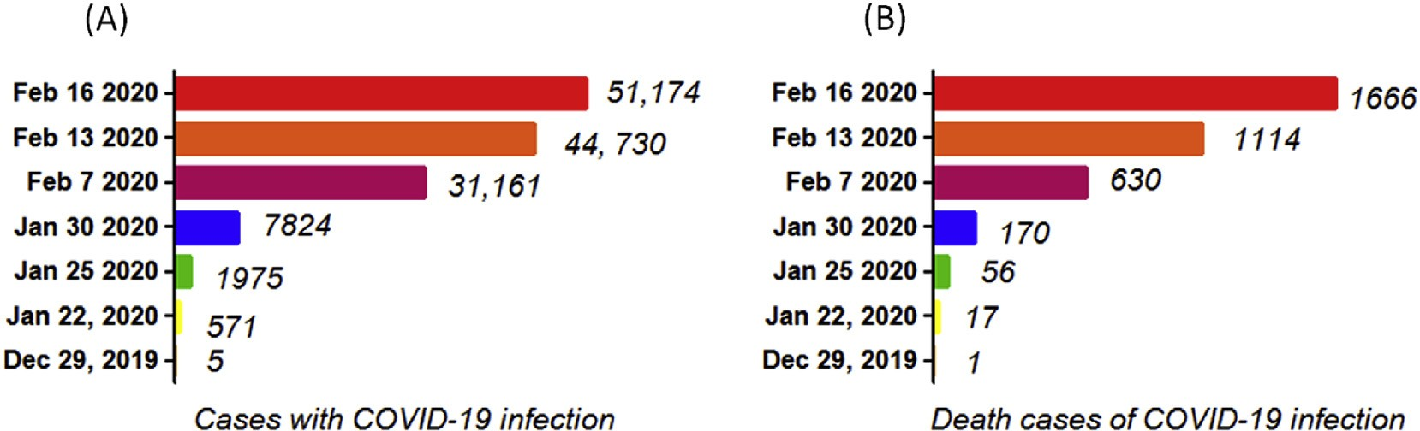

Figure 1. The chronological incidence of COVID-19 infections and death cases in China. Infections with COVID-19 appears in December 2019. At the time of preparing this manuscript, February 16, 2020 there have been 51,174 people who have contracted the infection in China, and more than 1666 people have died.

cases increased to 56 deaths [8]. The percentage of death among the reported 2684 cases of COVID-19 was approximately 2.84% as of Jan 25, 2020 and the median age of the deaths was 75 (range 48–89) years [8].

Patients infected with COVID-19 showed higher leukocyte numbers, abnormal respiratory ﬁndings, and increased levels of plasma pro-in- ﬂammatory cytokines. One of the COVID-19 case reports showed a patient at 5 days of fever presented with a cough, coarse breathing sounds of both lungs, and a body temperature of 39.0 °C. The patient's sputum showed positive real-time polymerase chain reaction results that conﬁrmed COVID-19 infection [14]. The laboratory studies showed leucopenia with leukocyte counts of 2.91 × 10^9 cells/L of which 70.0% were neutrophils. Additionally, a value of 16.16 mg/L of blood C-reactive protein was noted which is above the normal range

(0–10 mg/L). High erythrocyte sedimentation rate and D-dimer were also observed [14]. The main pathogenesis of COVID-19 infection as a

respiratory system targeting virus was severe pneumonia, RNAaemia, combined with the incidence of ground-glass opacities, and acute car- diac injury [6]. Signiﬁcantly high blood levels of cytokines and che- mokines were noted in patients with COVID-19 infection that included IL1-β, IL1RA, IL7, IL8, IL9, IL10, basic FGF2, GCSF, GMCSF, IFNγ, IP10,

MCP1, MIP1α, MIP1β, PDGFB, TNFα, and VEGFA. Some of the severe

cases that were admitted to the intensive care unit showed high levels of pro-inﬂammatory cytokines including IL2, IL7, IL10, GCSF, IP10, MCP1, MIP1α, and TNFα that are reasoned to promote disease severity [6].

1. Transmission

Based on the large number of infected people that were exposed to the wet animal market in Wuhan City where live animals are routinely sold, it is suggested that this is the likely zoonotic origin of the COVID-

19. Eﬀorts have been made to search for a reservoir host or inter- mediate carriers from which the infection may have spread to humans. Initial reports identiﬁed two species of snakes that could be a possible reservoir of the COVID-19. However, to date, there has been no con- sistent evidence of coronavirus reservoirs other than mammals and birds [10,18]. Genomic sequence analysis of COVID-19 showed 88% identity with two bat-derived severe acute respiratory syndrome (SARS)-like coronaviruses [19,20], indicating that mammals are the most likely link between COVID-19 and humans. Several reports have suggested that person-to-person transmission is a likely route for spreading COVID-19 infection. This is supported by cases that occurred within families and among people who did not visit the wet animal market in Wuhan [13,21]. Person-to-person transmission occurs pri- marily via direct contact or through droplets spread by coughing or sneezing from an infected individual. In a small study conducted on women in their third trimester who were conﬁrmed to be infected with the coronavirus, there was no evidence that there is transmission from mother to child. However, all pregnant mothers underwent cesarean sections, so it remains unclear whether transmission can occur during vaginal birth. This is important because pregnant mothers are relatively more susceptible to infection by respiratory pathogens and severe pneumonia ([https://www.thelancet.com](https://www.thelancet.com/), DOI:[https://doi.org/10.](https://doi.org/10.1016/S0140-6736(20)30360-3) [1016/S0140-6736(20)30360-3](https://doi.org/10.1016/S0140-6736(20)30360-3)).

The binding of a receptor expressed by host cells is the ﬁrst step of

viral infection followed by fusion with the cell membrane. It is reasoned that the lung epithelial cells are the primary target of the virus. Thus, it has been reported that human-to-human transmissions of SARS-CoV occurs by the binding between the receptor-binding domain of virus spikes and the cellular receptor which has been identiﬁed as angio- tensin-converting enzyme 2 (ACE2) receptor [20,22]. Importantly, the sequence of the receptor-binding domain of COVID-19 spikes is similar to that of SARS-CoV. This data strongly suggests that entry into the host cells is most likely via the ACE2 receptor [20].

1. Phylogenetic analysis

World Health Organisation (WHO) has classiﬁed COVID-19 as a β CoV of group 2B [23]. Ten genome sequences of COVID-19 obtained from a total of nine patients exhibited 99.98% sequence identity [19].

Another study showed there was 99.8–99.9% nucleotide identity in

isolates from ﬁve patients and the sequence results revealed the pre- sence of a new beta-CoV strain [5]. The genetic sequence of the COVID- 19 showed more than 80% identity to SARS-CoV and 50% to the MERS- CoV [5,19], and both SARS-CoV and MERS-CoV originate in bats [24]. Thus, the evidence from the phylogenetic analysis indicates that the COVID-19 belongs to the genus betacoronavirus, which includes SARS- CoV, that infects humans, bats, and wild animals [25].

COVID-19 represents the seventh member of the coronavirus family that infects humans and has been classiﬁed under the orthocoronavir- inae subfamily. The COVID-19 forms a clade within the subgenus sar- becovirus [25]. Based on the genetic sequence identity and the phylo- genetic reports, COVID-19 is suﬃciently diﬀerent from SARS-CoV and it can thus be considered as a new betacoronavirus that infects humans. The COVID-19 most likely developed from bat origin coronaviruses. Another piece of evidence that supports the COVID-19 is of bat origin is the existence of a high degree of homology of the ACE2 receptor from a diversity of animal species, thus implicating these animal species as possible intermediate hosts or animal models for COVID-19 infections [20]. Moreover, these viruses have a single intact open reading frame on gene 8, which is a further indicator of bat-origin CoVs. However, the amino acid sequence of the tentative receptor-binding domain re- sembles that of SARS-CoV, indicating that these viruses might use the same receptor [5].

1. Therapeutics/treatment options

The person-to-person transmission of COVID-19 infection led to the isolation of patients that were administered a variety of treatments. At present, there are no speciﬁc antiviral drugs or vaccine against COVID- 19 infection for potential therapy of humans. The only option available is using broad-spectrum antiviral drugs like Nucleoside analogues and also HIV-protease inhibitors that could attenuate virus infection until the speciﬁc antiviral becomes available [7]. The treatment that have so far been attempted showed that 75 patients were administrated existing antiviral drugs. The course of treatment included twice a day oral ad-

ministration of 75 mg oseltamivir, 500 mg lopinavir, 500 mg ritonavir and the intravenous administration of 0·25 g ganciclovir for 3–14 days [26]. Another report showed that the broad-spectrum antiviral re- mdesivir and chloroquine are highly eﬀective in the control of 2019-

nCoV infection in vitro. These antiviral compounds have been used in human patients with a safety track record. Thus, these therapeutic agents can be considered to treat COVID-19 infection [27]. Further- more, there are a number of other compounds that are in development. These include the clinical candidate EIDD-2801 compound that has shown high therapeutic potential aganist seasonal and pandemic in- ﬂuenza virus infections and this represents another potential drug to be considered for the treatment of COVID-19 infection [28]. Along those lines, until more speciﬁc therapeutics become available, it is reasonable to consider more broad-spectrum antivirals that provide drug treatment options for COVID-19 infection include Lopinavir/Ritonavir, Neur- aminidase inhibitors, peptide (EK1), RNA synthesis inhibitors. It is clear however, that more research is urgently needed to identify novel che- motherapeutic drugs for treating COVID-19 infections. In order to de- velop pre-and post-exposure prophylaxis against COVID-19, there is an urgent need to establish an animal model to replicate the severe disease currently observed in humans. Several groups of scientists are currently working hard to develop a nonhuman primate model to study COVID- 19 infection to establish fast track novel therapeutics and for the testing of potential vaccines in addition to providing a better understanding of virus-host interactions.

1. Future directions to control the spread of the disease

Extensive measures to reduce person-to-person transmission of COVID-19 are required to control the current outbreak. Special atten- tion and eﬀorts to protect or reduce transmission should be applied in susceptible populations including children, health care providers, and elderly people. A guideline was published for the medical staﬀ, healthcare providers, and, public health individuals and researchers who are interested in the 2019-nCoV [29]. The early death cases of COVID-19 outbreak occurred primarily in elderly people, possibly due to a weak immune system that permits faster progression of viral in- fection [8,12]. The public services and facilities should provide de- contaminating reagents for cleaning hands on a routine basis. Physical contact with wet and contaminated objects should be considered in dealing with the virus, especially agents such as faecal and urine samples that can potentially serve as an alternative route of transmis- sion [15,16]. China and other countries including the US have im- plemented major prevention and control measures including travel screenings to control further spread of the virus [13]. Epidemiological changes in COVID-19 infection should be monitored taking into account potential routes of transmission and subclinical infections, in addition to the adaptation, evolution, and virus spread among humans and possible intermediate animals and reservoirs. There remains a con- siderable number of questions that need to be addressed. These include, but are not limited to, details about who and how many have been tested, what proportion of these turned positive and whether this rate remains constant or variable. Very few paediatric cases have so far been reported; is this due to lack of testing or a true lack of infection/sus- ceptibility? Of the ones that have so far been tested, how many have developed severe disease and how many were tested positive but showed no clinical sign of disease? There are some basic questions that would provide a framework for which more speciﬁc and detailed public health measures can be implemented.

Declaration of competing interest

The authors declare no conﬂicts of interest.

Acknowledgements

This work is partially supported by National Institute of Allergy and Infectious Diseases Grant R01 AI129745 to SNB. We thank Ms. Michellie Thurman for editorial help.

References

* 1. Bogoch, A. Watts, A. Thomas-Bachli, C. Huber, M.U.G. Kraemer, K. Khan, Pneumonia of unknown etiology in wuhan, China: potential for international spread via commercial air travel, J. Trav. Med. (2020), [https://doi.org/10.1093/jtm/](https://doi.org/10.1093/jtm/taaa008) [taaa008.](https://doi.org/10.1093/jtm/taaa008)
  2. H. Lu, C.W. Stratton, Y.W. Tang, Outbreak of pneumonia of unknown etiology in wuhan China: the mystery and the miracle, J. Med. Virol. 92 (4) (2020) 401–402, [https://doi.org/10.1002/jmv.25678.](https://doi.org/10.1002/jmv.25678)
  3. S. Zhao, Q. Lin, J. Ran, S.S. Musa, G. Yang, W. Wang, et al., Preliminary estimation of the basic reproduction number of novel coronavirus (2019-nCoV) in China, from 2019 to 2020: a data-driven analysis in the early phase of the outbreak, Int. J. Infect. Dis. : IJID : Oﬀ. Publ. Int. Soc. Infect. Dis. 92 (2020) 214–217, [https://doi.](https://doi.org/10.1016/j.ijid.2020.01.050) [org/10.1016/j.ijid.2020.01.050.](https://doi.org/10.1016/j.ijid.2020.01.050)
  4. A. Du Toit, Outbreak of a novel coronavirus, Nat. Rev. Microbiol. 18 (123) (2020), [https://doi.org/10.1038/s41579-020-0332-0.](https://doi.org/10.1038/s41579-020-0332-0)
  5. L.L. Ren, Y.M. Wang, Z.Q. Wu, Z.C. Xiang, L. Guo, T. Xu, et al., Identiﬁcation of a

novel coronavirus causing severe pneumonia in human: a descriptive study, Chinese Med J (2020), [https://doi.org/10.1097/CM9.0000000000000722.](https://doi.org/10.1097/CM9.0000000000000722)

* 1. C. Huang, Y. Wang, X. Li, L. Ren, J. Zhao, Y. Hu, et al., Clinical features of patients infected with 2019 novel coronavirus in Wuhan, China, Lancet 395 (10223) (2020) 497–506, [https://doi.org/10.1016/S0140-6736(20)30183-5.](https://doi.org/10.1016/S0140-6736(20)30183-5)
  2. H. Lu, Drug treatment options for the 2019-new coronavirus (2019-nCoV), Biosci.

Trends (2020), [https://doi.org/10.5582/bst.2020.01020.](https://doi.org/10.5582/bst.2020.01020)

* 1. W. Wang, J. Tang, F. Wei, Updated understanding of the outbreak of 2019 novel coronavirus (2019-nCoV) in Wuhan, China, J. Med. Virol. 92 (4) (2020) 441–447, [https://doi.org/10.1002/jmv.25689.](https://doi.org/10.1002/jmv.25689)
  2. [H. Nishiura, S.M. Jung, N.M. Linton, R. Kinoshita, Y. Yang, K. Hayashi, et al., The](http://refhub.elsevier.com/S0896-8411(20)30046-9/sref9) [extent of transmission of novel coronavirus in wuhan, China, 2020, J. Clin. Med. 9](http://refhub.elsevier.com/S0896-8411(20)30046-9/sref9) [(2020).](http://refhub.elsevier.com/S0896-8411(20)30046-9/sref9)
  3. M. Bassetti, A. Vena, D. Roberto Giacobbe, The Novel Chinese Coronavirus (2019- nCoV) Infections: challenges for ﬁghting the storm, Eur. J. Clin. Invest. (2020) e13209, , [https://doi.org/10.1111/eci.13209.](https://doi.org/10.1111/eci.13209)
  4. M.L. Holshue, C. DeBolt, S. Lindquist, K.H. Lofy, J. Wiesman, H. Bruce, et al., First case of 2019 novel coronavirus in the United States, N. Engl. J. Med. (2020), [https://doi.org/10.1056/NEJMoa2001191.](https://doi.org/10.1056/NEJMoa2001191)
  5. Q. Li, X. Guan, P. Wu, X. Wang, L. Zhou, Y. Tong, et al., Early transmission dy- namics in wuhan, China, of novel coronavirus-infected pneumonia, N. Engl. J. Med. (2020), [https://doi.org/10.1056/NEJMoa2001316.](https://doi.org/10.1056/NEJMoa2001316)
  6. W.G. Carlos, C.S. Dela Cruz, B. Cao, S. Pasnick, S. Jamil, Novel wuhan (2019-nCoV) coronavirus, Am. J. Respir. Crit. Care Med. 201 (4) (2020) 7–8, [https://doi.org/10.](https://doi.org/10.1164/rccm.2014P7) [1164/rccm.2014P7.](https://doi.org/10.1164/rccm.2014P7)
  7. J. Lei, J. Li, X. Li, X. Qi, CT imaging of the 2019 novel coronavirus (2019-nCoV) pneumonia, Radiology (2020) 200236, [https://doi.org/10.1148/radiol.](https://doi.org/10.1148/radiol.2020200236) [2020200236.](https://doi.org/10.1148/radiol.2020200236)
  8. [A. Assiri, J.A. Al-Taw](http://refhub.elsevier.com/S0896-8411(20)30046-9/sref15)ﬁ[q, A.A. Al-Rabeeah, F.A. Al-Rabiah, S. Al-Hajjar, A. Al-](http://refhub.elsevier.com/S0896-8411(20)30046-9/sref15) [Barrak, et al., Epidemiological, demographic, and clinical characteristics of 47 cases](http://refhub.elsevier.com/S0896-8411(20)30046-9/sref15) [of Middle East respiratory syndrome coronavirus disease from Saudi Arabia: a de-](http://refhub.elsevier.com/S0896-8411(20)30046-9/sref15)

[scriptive study, Lancet Infect. Dis. 13 (2013) 752–761.](http://refhub.elsevier.com/S0896-8411(20)30046-9/sref15)

* 1. [N. Lee, D. Hui, A. Wu, P. Chan, P. Cameron, G.M. Joynt, et al., A major outbreak of](http://refhub.elsevier.com/S0896-8411(20)30046-9/sref16) [severe acute respiratory syndrome in Hong Kong, N. Engl. J. Med. 348 (2003)](http://refhub.elsevier.com/S0896-8411(20)30046-9/sref16) [1986–1994.](http://refhub.elsevier.com/S0896-8411(20)30046-9/sref16)
  2. L.T. Phan, T.V. Nguyen, Q.C. Luong, T.V. Nguyen, H.T. Nguyen, H.Q. Le, et al.,

Importation and human-to-human transmission of a novel coronavirus in Vietnam, N. Engl. J. Med. (2020), [https://doi.org/10.1056/NEJMc2001272.](https://doi.org/10.1056/NEJMc2001272)

* 1. W. Ji, W. Wang, X. Zhao, J. Zai, X. Li, Homologous recombination within the spike glycoprotein of the newly identiﬁed coronavirus may boost cross-species trans- mission from snake to human, J. Med. Virol. 92 (4) (2020) 433–440, [https://doi.](https://doi.org/10.1002/jmv.25682) [org/10.1002/jmv.25682.](https://doi.org/10.1002/jmv.25682)
  2. R. Lu, X. Zhao, J. Li, P. Niu, B. Yang, H. Wu, et al., Genomic characterisation and epidemiology of 2019 novel coronavirus: implications for virus origins and receptor binding, Lancet 395 (10224) (2020) 565–574, [https://doi.org/10.1016/S0140-](https://doi.org/10.1016/S0140-6736(20)30251-8)

[6736(20)30251-8.](https://doi.org/10.1016/S0140-6736(20)30251-8)

* 1. Y. Wan, J. Shang, R. Graham, R.S. Baric, F. Li, Receptor recognition by novel cor- onavirus from Wuhan: an analysis based on decade-long structural studies of SARS, J. Virol. (2020), [https://doi.org/10.1128/JVI.00127-20.](https://doi.org/10.1128/JVI.00127-20)
  2. [P. Wu, X. Hao, E.H.Y. Lau, J.Y. Wong, K.S.M. Leung, J.T. Wu, et al., Real-time](http://refhub.elsevier.com/S0896-8411(20)30046-9/sref21) [tentative assessment of the epidemiological characteristics of novel coronavirus](http://refhub.elsevier.com/S0896-8411(20)30046-9/sref21) [infections in Wuhan, China, as at 22 January 2020, Euro Surveill. 25 (2020).](http://refhub.elsevier.com/S0896-8411(20)30046-9/sref21)
  3. [J.A. Jaimes, J.K. Millet, A.E. Stout, N.M. Andre, G.R. Whittaker, A tale of two](http://refhub.elsevier.com/S0896-8411(20)30046-9/sref22) [viruses: the distinct spike glycoproteins of feline coronaviruses, Viruses 12 (2020).](http://refhub.elsevier.com/S0896-8411(20)30046-9/sref22)
  4. [D.S. Hui, E. IA, T.A. Madani, F. Ntoumi, R. Kock, O. Dar, et al., The continuing](http://refhub.elsevier.com/S0896-8411(20)30046-9/sref23) [2019-nCoV epidemic threat of novel coronaviruses to global health - the latest 2019](http://refhub.elsevier.com/S0896-8411(20)30046-9/sref23) [novel coronavirus outbreak in Wuhan, China, Int. J. Infect. Dis. 91 (2020) 264–266.](http://refhub.elsevier.com/S0896-8411(20)30046-9/sref23)
  5. [J. Cui, F. Li, Z.L. Shi, Origin and evolution of pathogenic coronaviruses, Nat. Rev.](http://refhub.elsevier.com/S0896-8411(20)30046-9/sref24)

[Microbiol. 17 (2019) 181–192.](http://refhub.elsevier.com/S0896-8411(20)30046-9/sref24)

* 1. N. Zhu, D. Zhang, W. Wang, X. Li, B. Yang, J. Song, et al., A novel coronavirus from patients with pneumonia in China, N. Engl. J. Med. 382 (2019) 727–733, [https://](https://doi.org/10.1056/NEJMoa2001017) [doi.org/10.1056/NEJMoa2001017 2020.](https://doi.org/10.1056/NEJMoa2001017)
  2. N. Chen, M. Zhou, X. Dong, J. Qu, F. Gong, Y. Han, et al., Epidemiological and clinical characteristics of 99 cases of 2019 novel coronavirus pneumonia in Wuhan, China: a descriptive study, Lancet 395 (10223) (2020) 507–513, [https://doi.org/](https://doi.org/10.1016/S0140-6736(20)30211-7) [10.1016/S0140-6736(20)30211-7.](https://doi.org/10.1016/S0140-6736(20)30211-7)
  3. [M. Wang, R. Cao, L. Zhang, X. Yang, J. Liu, M. Xu, et al., Remdesivir and](http://refhub.elsevier.com/S0896-8411(20)30046-9/sref27) [Chloroquine Eﬀectively Inhibit the Recently Emerged Novel Coronavirus (2019-](http://refhub.elsevier.com/S0896-8411(20)30046-9/sref27) [nCoV) in Vitro, Cell research, 2020.](http://refhub.elsevier.com/S0896-8411(20)30046-9/sref27)
  4. [M. Toots, J.J. Yoon, R.M. Cox, M. Hart, Z.M. Sticher, N. Makhsous, et al.,](http://refhub.elsevier.com/S0896-8411(20)30046-9/sref28) [Characterization of orally e](http://refhub.elsevier.com/S0896-8411(20)30046-9/sref28)ﬃ[cacious in](http://refhub.elsevier.com/S0896-8411(20)30046-9/sref28)ﬂ[uenza drug with high resistance barrier in](http://refhub.elsevier.com/S0896-8411(20)30046-9/sref28) [ferrets and human airway epithelia, Sci. Transl. Med. (2019) 11.](http://refhub.elsevier.com/S0896-8411(20)30046-9/sref28)
  5. [Y.H. Jin, L. Cai, Z.S. Cheng, H. Cheng, T. Deng, Y.P. Fan, et al., A rapid advice](http://refhub.elsevier.com/S0896-8411(20)30046-9/sref29) [guideline for the diagnosis and treatment of 2019 novel coronavirus (2019-nCoV)](http://refhub.elsevier.com/S0896-8411(20)30046-9/sref29) [infected pneumonia (standard version), Mil. Med. Res. 7 (2020) 4.](http://refhub.elsevier.com/S0896-8411(20)30046-9/sref29)